The Tokorozawa International Forum is an event where people from all over the world gather to meet, connect, and interact.
English
The 31st Tokorozawa International Forum
입장 무료.
대중교통(전철이나 버스)으로 와주세요. 도코로자와시 국제교류포럼
Everyone is welcome!
Enjoy conversations with people from different countries and experience Japanese culture as well as cultures from around the world.
Date & Time: Sunday, March 8, 2026 | 12:00-4:30PM (Doors open at 11:30AM)
Location：Shintokorozawa Community Development Center
※Please be aware that this year’s venue is different from previous years.
Admission: Free
Please use public transportation (train or bus).

Program
Stage Events:
・Speeches by foreign residents
・Music and dance performances from around the world
・High school student performances
・And more!
Interaction Area:
・Talk with people from many countries
・Attend talks and presentations
Cultural Experiences:
・Try on traditional costumes from around the world
・Experience international sports
・Hula dance workshops
・Kendama (Japanese cup-and-ball game)
・And more!
Pre-Event Exhibition (Panels & Displays)
Learn about Tokorozawa City initiatives and volunteer organizations that support foreign residents.
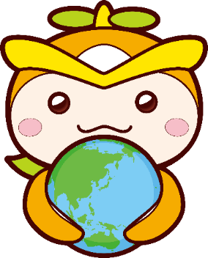
Dates: March 4 (Wed) – March 6 (Fri), 2026
Time: 10:00 AM – 3:00 PM daily
Location: Tokorozawa City Hall, 1st Floor Hall

